醫學院忘年會
College of Medicine , Taipei Medical University Year-End Party
January 21st 2008
In order to appreciate teachers and the colleagues for the passing year, the Year-End party is held on Jan. 21st 2008. About 150 people and 10 honored professors attend the party. At the party, we presents mementos to Professor Ko and Professor Tsai, both will retire this year. Also, we show our appreciations to Assistant Professor Chen who will become part-time teacher this coming year. Lots of generous delicacies and lucky lottery make attendee delighted. It is really a great gathering of distinguished guests and honored professors.
為感 謝 老師及同仁們過去一年來的辛勞，醫學院於 97年1月21日 中午假醫學綜合大樓8樓徐千田紀念廳舉辦醫學院忘年會。大約有150位同仁與會，並有名譽教授陳定堯、蕭柳青、林守田、郭憲壽、洪清霖、鍾文政、翁國榮、黃德修、顏焜熒出席。同時，歡送榮退的藥理學科 柯文昌 教授及醫學科學研究所 蔡郁惠 教授，亦感謝將轉任兼任教師的醫學系行政老師解剖學科陳金 山助理 教授。除備有各式美味餐點，並與辦摸彩活動與大家同樂。
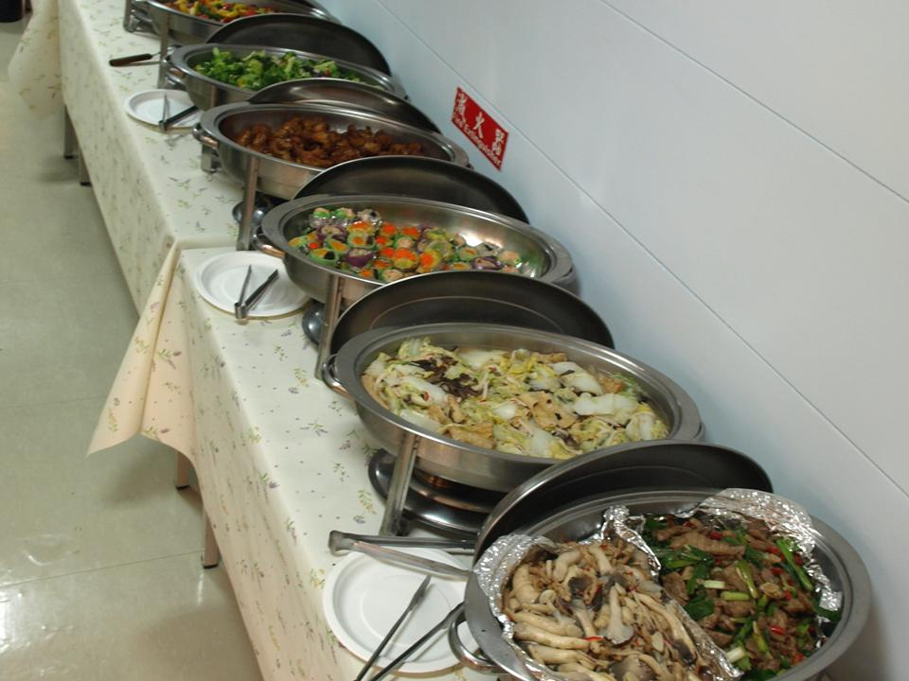
↑醫學院忘年會豐盛的食物Generous delicacies.
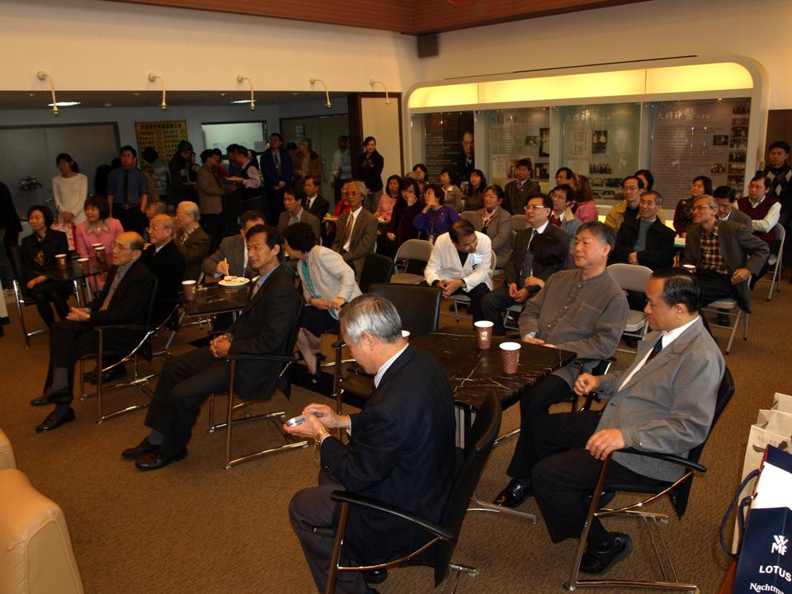
↑現場高朋滿座Great gathering of distinguished guests.
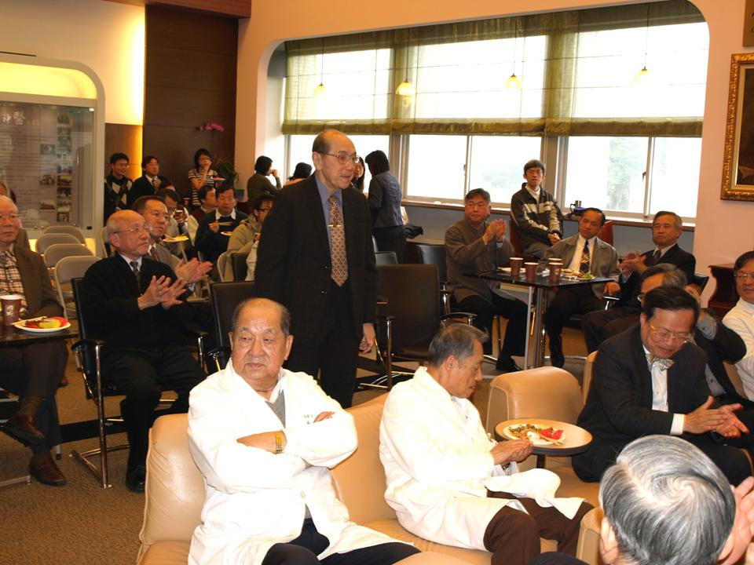
↑現場嘉賓雲集-名譽教授Honored Professors
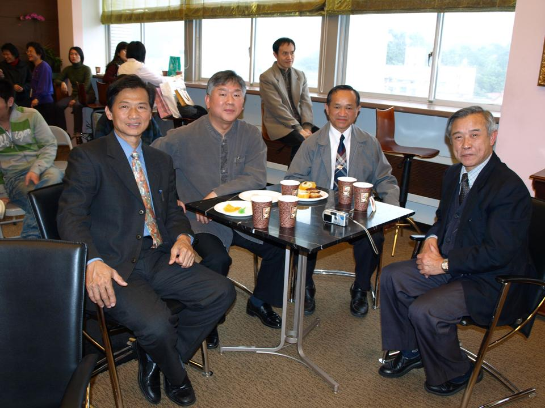
↑Honored Professors attend Year-End Party
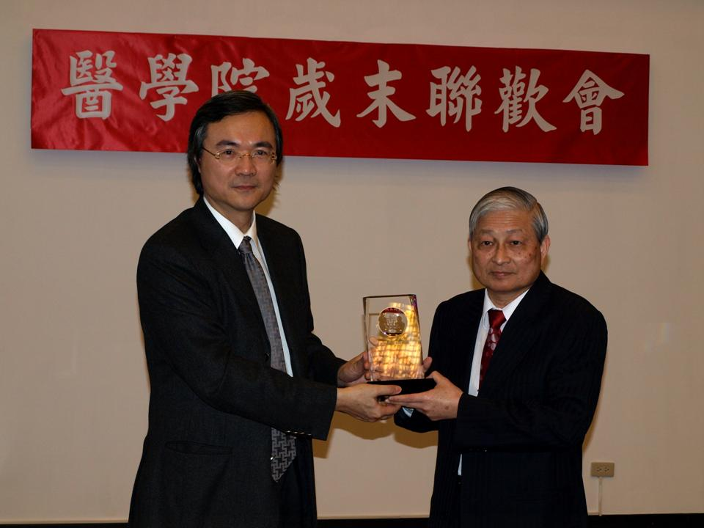
↑柯文昌 教授榮退，曾院長贈紀念獎牌致意Dean Tzeng presents crystal medal to Professor Ko, the retire professor this year.
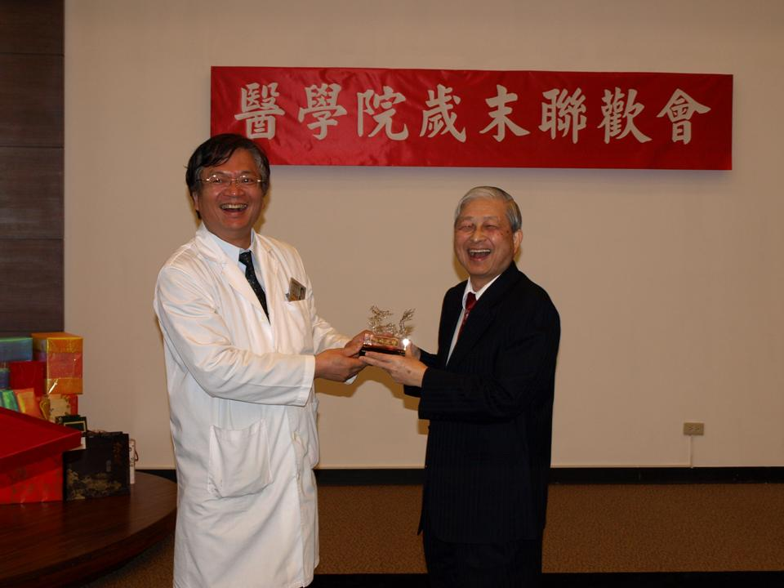
↑醫學系謝銘勳主任頒贈水晶給 柯文昌 教授Chair Hsieh also gives away memento to Professor Ko.
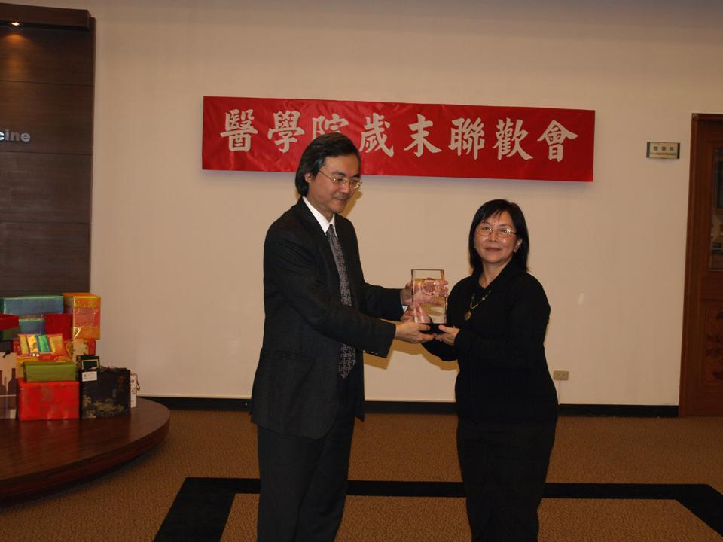
↑蔡郁惠 教授榮退，曾院長頒贈紀念致意Dean Tzeng presents crystal medal to Professor Tsai, the retire professor this year.
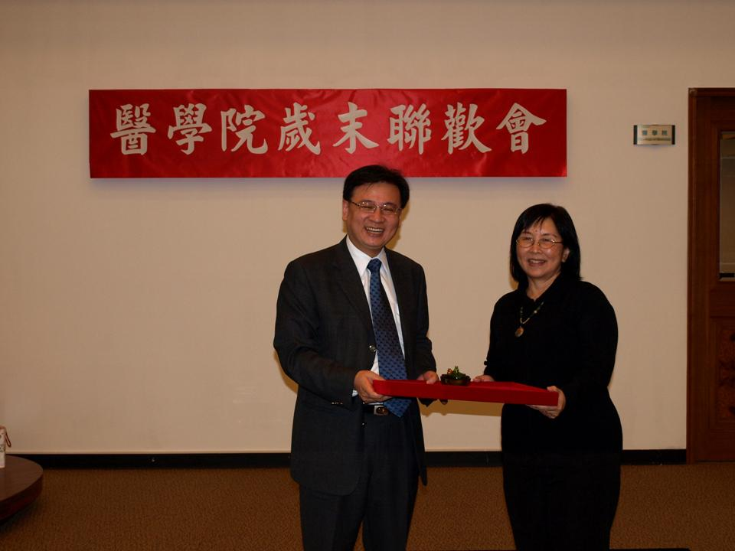
↑研發長感謝蔡郁惠教Director Lin also shows our appreciation to Professor Tsai.
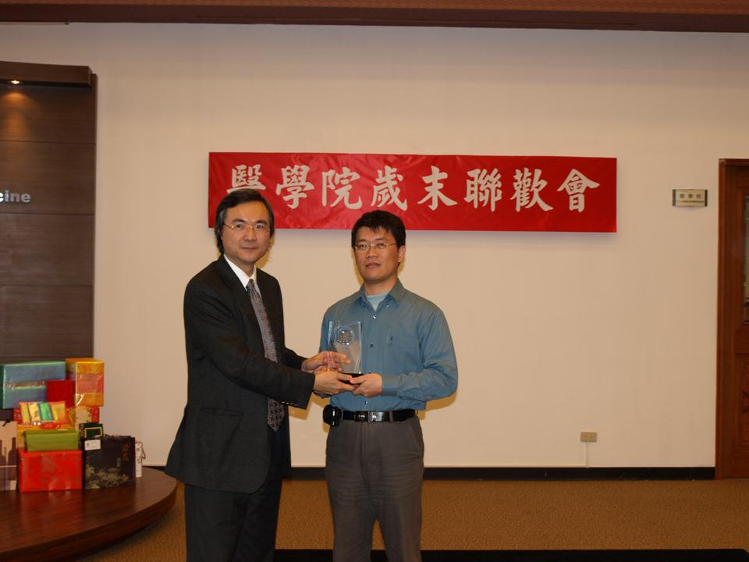
↑曾院長頒贈紀念獎牌給 陳金山 老師，感謝其對醫學院之貢獻Dean Tzeng presents crystal medal to Assistant Professor Chen.
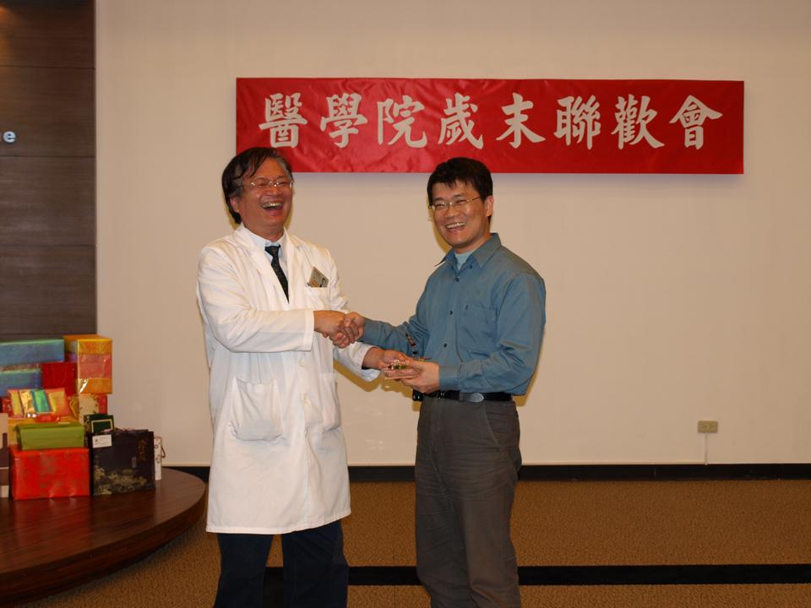
↑謝主任贈送紀念品給 陳金山 老師Chair Hsieh also gives away memento to Assistant Professor Chen.
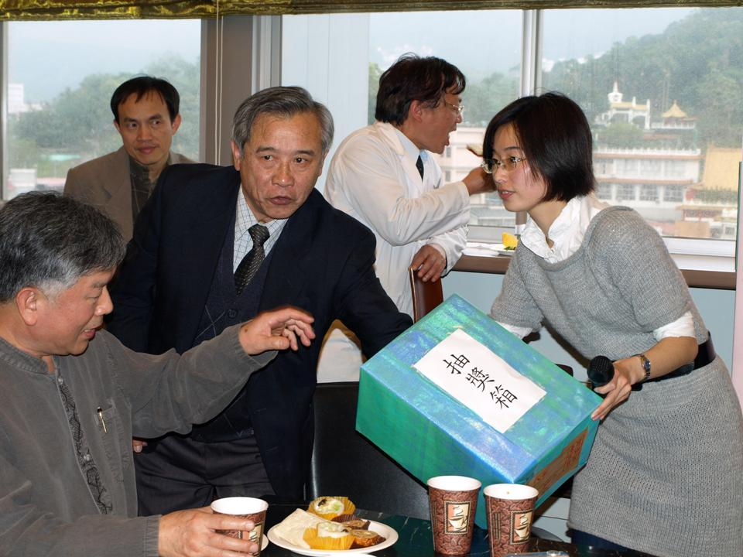
↑抽獎活動Year-End party lucky lottery.
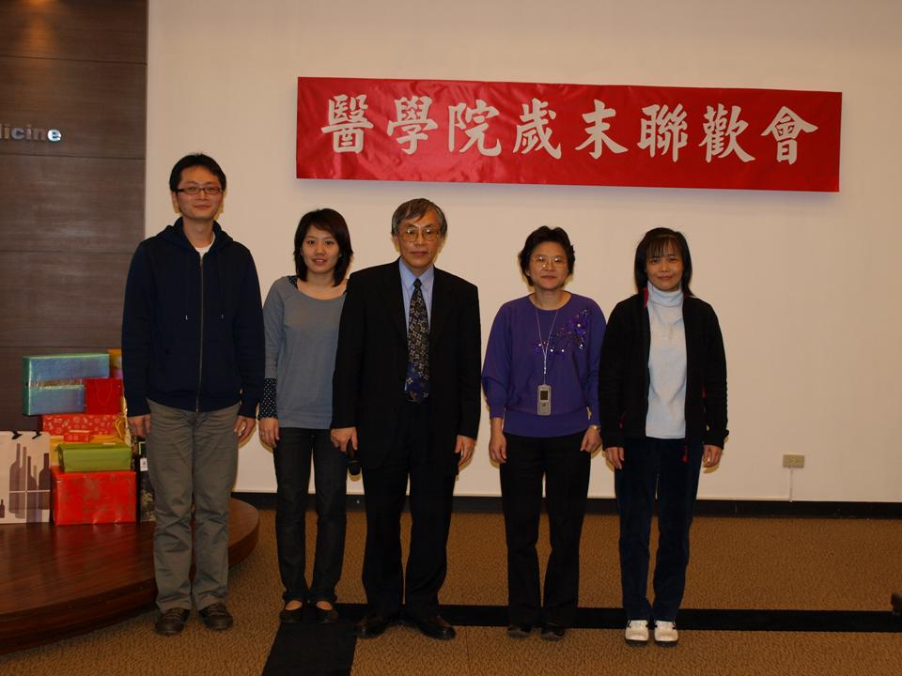
↑被校長抽到得獎的幸運兒President picks up 4 lucky winners.
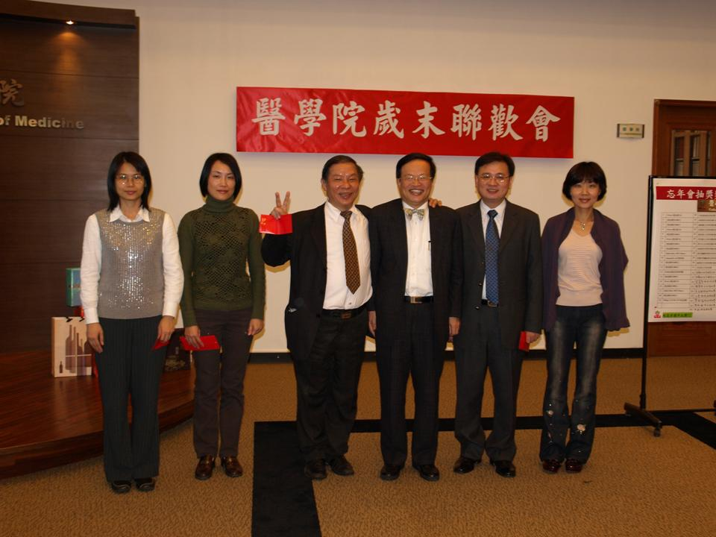
↑被洪副校長抽到得獎的教師們Winners are drawn out by Deputy president Hong.
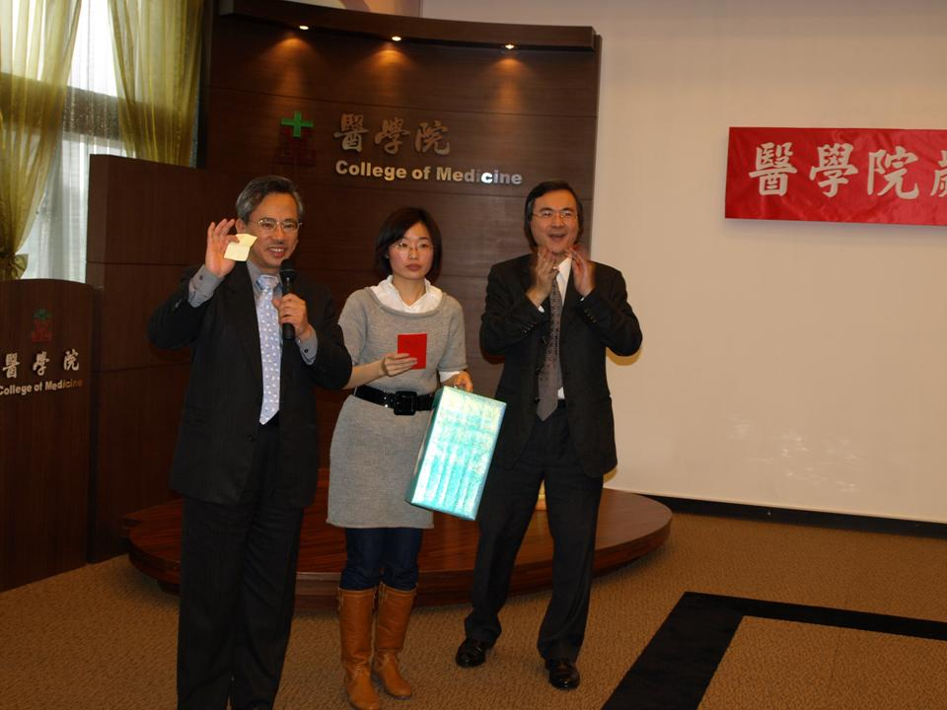
↑邱副校長抽到的得獎人請出列~~Who is picked by Deputy president Chiu? Please stand up~~
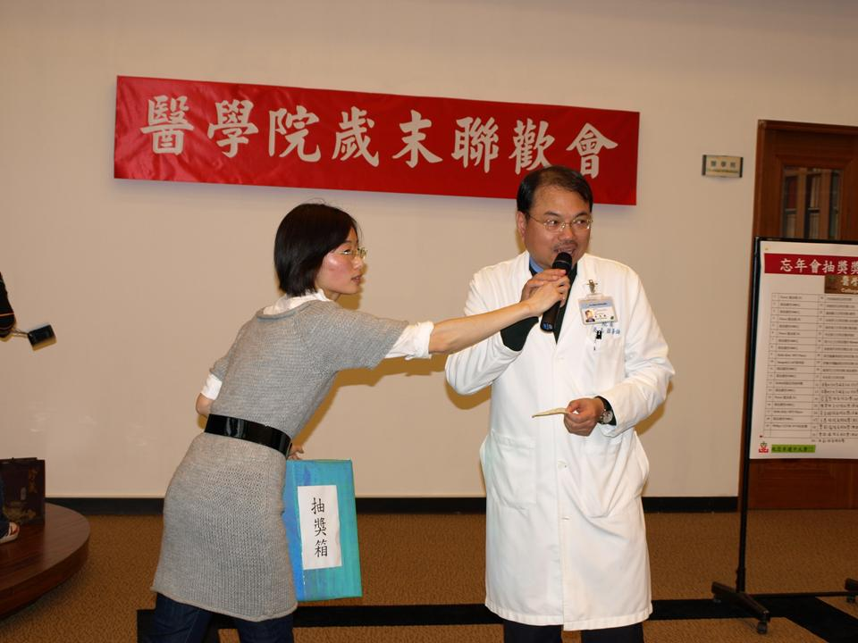
↑附醫吳志雄院長宣布得獎者President Wu of Taipei Medical University Hospital announces the winner.
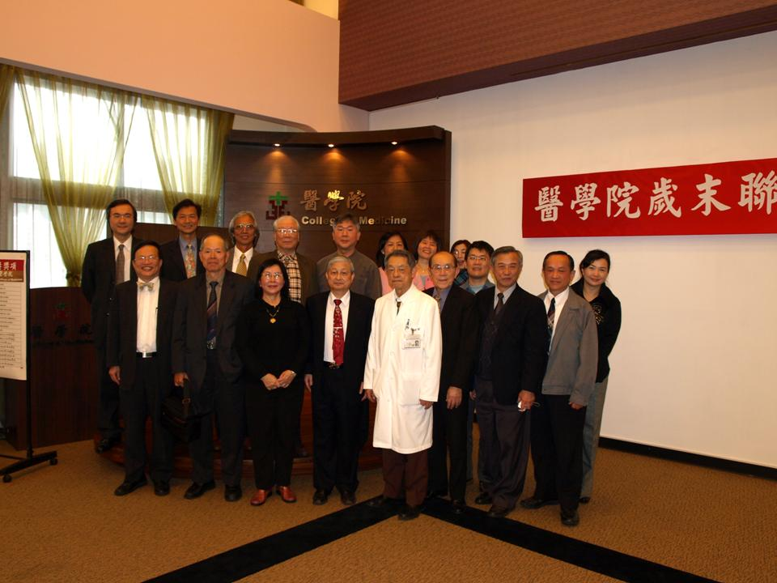
↑全體貴賓合影留念Distinguish guests and honored professors have a group photo taken.

